**Electronic Broom for Household Cleaning**

Akash V. Shekhavat

*Dept. of E&TC, VIT* Pune India

[*akash.shekhavat20@vit.edu*](mailto:akash.shekhavat20@vit.edu)

Madhuri K. Shelke

*Dept. of E&TC, VIT Pune India*

[*madhuri.shelke20@vit.edu*](mailto:madhuri.shelke20@vit.edu)

*Chetan S. Shinde*

*Dept. of E&TC, VIT* Pune India

[*chetan.shinde20@vit.edu*](mailto:chetan.shinde20@vit.edu)

Shripad  S. Bhatlawande

*Dept. of E&TC, VIT* Pune India

[*shripad.bhatlawande@vit.edu*](mailto:shripad.bhatlawande@vit.edu)

***Abstract: Cleanliness is a very vital aspect of our life, of which household cleaning plays an important role. With the increasing demand for automated cleaning solutions, electronic bots have become an attractive option for many households. These bots are designed to navigate and clean various surfaces, minimizing the need for human intervention. However, traditional electronic bots have limitations, such as inaccurate dust detection and obstacles avoidance. To address these limitations, the proposed model has demonstrated the development of an electronic bot that that can be controlled manually as well as automatically through the use of an android application. It has been integrated with OpenCV for dust prediction and an ultrasonic sensor for obstacle avoidance. The bot uses a combination of suction and mopping mechanisms to clean surfaces. The proposed bot aims to improve the efficiency and convenience of household cleaning while reducing the physical effort required from the user, and ensuring that the cleaning is optimized based on the level of dust present in the environment.***

***Keywords: Autonomous, Electronic bot, household cleaning, manual control, mopping, vacuuming***

I.INTRODUCTION

Increasing the development in automation and industries leads to an increase in the work of humans. For their hectic daily lives, humans want to get rid of the small household chores, especially floor cleaning. Floor cleaning, though it is simple, Many do not prefer to do this; they hire workers for this work. People carry out the task of cleaning their homes on a regular basis. Every day, people have to do the repetitive task of household cleaning. All family members are busy with their office work and do not get adequate time to clean the house [1].

Robots for cleaning purpose have been achieving attention amongst various industries all over the world, of which household or office floor cleaning robots being the most widespread.Hence there is a need to develop a cleaning robot with a reasonable price that is affordable for common people, which could assist them in performing repetitive tasks every day while also giving attention to the amount of manpower required and improving qualities to their best level. Currently available vacuum cleaner systems have limited suction power. Also, they are costly and complex in structure. To solve this problem, many robots were designed and developed. A vacuum cleaner has long been an electro-mechanical appliance used to clean floors, furniture, and rugs and carpets. In today's more sophisticated households, vacuum cleaners are so popular that many consumers are paying much attention to robotic vacuums [2].

In the proposed model, a smart manually as well automatically operated compact floor cleaning bot has been developed with the enhancement of functions like floor cleaning and mopping. The bot is equipped with ultrasonic sensor to detect and navigate obstacles, a camera for dust detection and prediction integrated with OpenCV. The manual mode allows users to control the bot's movement and cleaning modes through a smartphone application. The Automatic mode enables the bot to operate autonomously with the help of obstacle detection and adjusting its cleaning mechanism according to the detected dust predictions. The objective of this study was to evaluate the performance of the developed electronic bot and its ability to accurately predict dust and avoid obstacles. Through this study, the main aim was to provide an improved solution for automated household cleaning that can operate effectively and efficiently in real-world environments.

II.LITERATURE REVIEW

Cleaning and mopping is a very tedious task for members of the family who are working professionals. It becomes very difficult for them to manage their time for cleaning work along with their office work. A lot of labour and time are required for cleaning homes. So to tackle this, many manual and autonomously operated floor cleaning robots and machines are available in the market. The architecture, shape, size, and functionalities of the cleaning robot depend upon the work it is going to accompany. The autonomous cleaning robots are more technologically advanced than one that is manually operated. The most common functionalities are dusting and mopping. Path planning and obstacle avoidance are the major challenges we have to tackle while developing a cleaning robot. People make different attempts to develop self-made room-cleaning robots. Research paper [1/5] discusses the development of such a robot. The components they used are the HC-05 Bluetooth module, the Arduino microcontroller, ultrasonic sensors, the L293D motor drive, and lead acid batteries to power the entire model. Ultrasonic sensors look for obstacles and, if found, take a turn; if not found, they move forward, and the cleaning is done in a perpendicular path. This robot operates in both automatic and manual modes. It provides both cleaning and mopping mechanisms and is low-cost. It can work for almost 35 minutes once charged, but the power consumption is higher. [1]

Cleaning of walls and glass is a difficult task therefore an automatic wall+floor cleaning robot has been developed using Arduino mega,IR sensor,Hc 05 Bluetooth ,L298 motor driver, vacuum pump, electric ducted fan and BSC(Bluetooth serial controller) android app. Advantage is that it can be used to clean the floor as well as glass walls , so edges are cleaned properly. Limitation is that it cannot be controlled from long distance and a plain glass surface is required for cleaning [3]. Also street dusting is a very tedious task. Street Dust causes hazard to health .A brush and shovel is used by a sweeper to collect garbage on the roads and footpaths, which is a long time consuming method.  To make it simple, an Arduino based solar energy street cleaning machine is designed with a dust collecting bin. It is eco-friendly, lightweight and easy to use. Also the machine speed is controllable and can be varied. [4]

Multi-story buildings require staircase cleaning, which is a repetitive, hectic, and time-consuming task that calls for in-depth labour. This paper has discussed the manufacturing of cleaning robots with the help of vision-based mechanisms in order to perceive the measurements on the way to correct its motion and the clearance distance. The development of the bot has been done using the precept of modular mobility with a linear actuation mechanism. The disadvantage here is that there is a greater requirement for power. [5]

Current robots (round or D-configuration) are not able to reach corners, convex spaces, or concave regions within the cleaning surroundings; therefore, a robot with a backstepping layout used for motion control has been made. The design assures asymptotic path tracking. The controlling of the bot incorporates a robust backstepping controller in the outer loop for getting the changing kinematics and a traditional PID within the internal loop for pace management. This cascade is attached through a PID controller in order to correct the wheel orientation after every configuration exchange. The robot can be changed into three different configurations and has better area coverage for cleaning; it also has a complex structure. [6]

A robot whose motion can be controlled via voice instructions has been developed. The major use of such robots can be found in floor cleaning. User interaction will become easier with such a developed system. This has been done using the LabVIEW graphical programming language and a speech recognition algorithm. The algorithm is modified to use the warping time method algorithm using an embedded device, the RIO. Feature extraction has been done while keeping the critical frequency bandwidth, which is interpreted using different artificial models with accurate filters; this frequency is called the Mel Frequency Cepstral Coefficient (MFCC’s). The accuracy after attempting 160 voice commands in different pronunciations is about 91.48%. The myRIO device with this algorithm needs to be tested for computational complexity, which results in this voice command recognition algorithm not being sufficient. [20].

The paper [22] has discussed the need for automated cleaning robots to tackle our hectic lifestyles. The hardware components included ultrasonic sensors, LDR, video processing, an Arduino microcontroller, a motor driver, Bluetooth (HC05), and dc motors. The robot performs its task in three steps. The first step is to detect the garbage or trash, the second is to locate the robot near that garbage, and the third is to collect the garbage. The manufacturing price of this robot is quite high.

Omni-wheel floor cleaning robots are also a popular category of cleaning machines available on the market. The main advantage of such robots is that they can move in all directions. The author of the paper discusses developing an intelligent floor cleaning robot. He also talked about its features, like navigation and cleaning and polishing floors automatically. The author accomplished his goal in three simple steps: analysis, design architecture, implementation, and testing. The robot consists of an Omni wheel, and it is attached to a vacuum cleaner and floor polishing motor. Hardware components like a wheel motor, vacuum cleaner, polishing motor, Arduino microcontroller circuit, motor driver, and Bluetooth receiver were used in the robot. [24]

Totally autonomous robots can be a mess sometimes. They are intelligent enough to map our inner home environment, but sometimes we need hard cleaning or event-specific cleaning. So in such a situation, we need a robot that can run in both manual and autonomous modes. In Paper [25], the author discusses the idea of developing a cleaning robot that can run in two modes: manual and automatic. The author shares the features of the robot, like how it can detect obstacles and change its path and has a mopping facility for wet cleaning. Hardware components RF module, AT89S52 microcontroller, 4 gear DC motors, motor driver circuit, 12V DC supply, RF module, and LCD screen were being used in the project. The main disadvantage of this robot is that it does not have a proper navigation system for cleaning. The robot also doesn't have depth sensors for edge detection.

In paper [27], the author has discussed the development of a room-cleaning robot that can clean autonomously. The robot proposed in this paper has some features like floor mapping, dry cleaning, and wet cleaning. The robot can perform autonomous features like scheduling for a specific time and dumping dirt containers with a dumping mechanism. It has several features, like obstacle avoidance and edge detection. The author has made use of the Raspberry Pi to control all sensors. Robots autonomously reach the charging station as soon as less charging is detected. The robot will follow a spiral pattern for area coverage.

III. METHODOLOGY

*A.Design and fabrication of cleaning bot*

The design of the cleaning bot was created using Computer-Aided Design (CAD) software using SolidWorks software. The various parts of the bot, including the vacuum mechanism, mop mechanism, and battery compartment were modelled in 3D using the software. The cleaning bot was designed with two circular plates, which made up the top and bottom parts of the bot. The components such as the battery, motors, motor drivers, vacuum and mopping mechanism were situated between these two plates. The vacuum mechanism consisted of a high-powered motor that generates suction to pull dust and debris from the floor and it has direct contact with the surface of the floor. The mop mechanism is designed to activate only when no dust is detected, as determined by the dust detection system. This helps to conserve water and cleaning solutions and reduces the cleaning time. The cleaning bot was powered by a rechargeable battery, which is housed in a compartment in between the two circular plates. The battery provides enough power to allow the bot to operate for several hours on a single charge.

The process of modelling involved creating a detailed digital representation of each part, including its dimensions, shape, and orientation. The software allowed for precise measurements and adjustments to be made, ensuring that each part fit together correctly. The 3D cad model has been illustrated in fig. 1 after assembling all the components, which can be used as a floor cleaner with human interference required only on the setting up of the module on the floor.

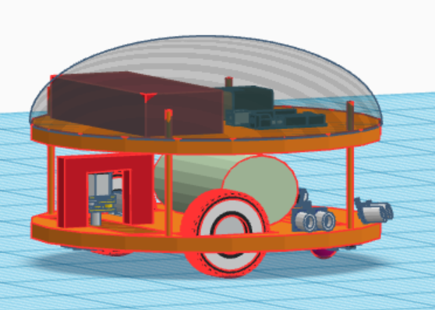

fig. 1: CAD model of the bot

Once the digital models were complete, they were used to create physical prototypes using a 3D printer. The printing process involved layer-by-layer deposition of plastic material until the entire part was created. This allowed for quick and efficient production of the various parts, as well as the ability to make adjustments to the design as needed. After the printing process was complete, the various parts were assembled to create the final cleaning bot. The components were carefully aligned in place to ensure that the bot operated efficiently and effectively. The design details for the bot are as shown in table 1. Acrylic material has been used to provide robustness to the bot.

Design consideration                    Specifications

Base diameter                                     30 cm

Base Thickness                                   0.6 cm

Total height of the body                      22 cm

Ground clearance                                7 cm

Base material                                      Acrylic

Table 1: Design details of the robot body

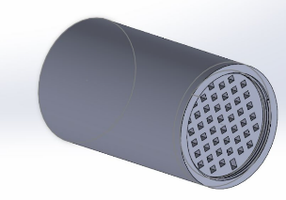 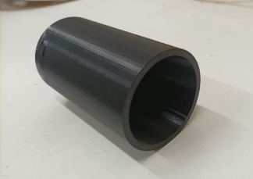

fig. 2: CAD model and 3d printed dust collector

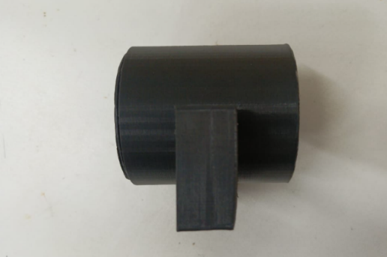

fig. 3: 3D printed motor mount

The CAD modelling process played a crucial role in the design and fabrication of the cleaning bot. The design of the cleaning bot was highly efficient and functional. The two circular plates, along with the various components situated between them, allowed for optimal placement and operation of the vacuum and mop mechanisms. The battery, motors, and motor drivers were also easily accessible and could be replaced or repaired as needed.

*B. Hardware integration*

The hardware integration of the electronic bot with dust prediction system and ultrasonic sensor for obstacle avoidance was achieved using the following components: Raspberry Pi, L293D motor driver, ultrasonic sensor, DC motors, switch, vacuum, and mopper. The Raspberry Pi served as the central control unit for the electronic bot. It was connected to the L293D motor driver, which controlled the speed and direction of the DC motors. The ultrasonic sensor was used to detect obstacles in the path of the bot, and it was connected to the Raspberry Pi as well. The vacuum and mopper were also connected to the bot and controlled by the Raspberry Pi.

As soon as the cleaning bot is turned on, each of the wheels of the robotic bot will start simultaneously, the robot will move in the forward direction, and the suction and mopping mechanisms will be turned on.

This wheeled vacuum cleaner bot is administered via wheel with the use of a DC geared motor. During the motion of the bot, the cleaning module is able to perform two functions at a time. First, it removes all the solid dust particles present on the floor using an electric vacuum suction fan placed at the front, which is called dry cleaning. After this process, the cleaning module performs a wet cleaning process with the assistance of water, a vacuum pump, and cleansing pads, which enables it to efficiently cleanse the surface. The vehicle with motor driver IC L293D is used; hence, this driver gets the records from the Raspberry Pi and makes the motor drive as desired. The connections of the various components with the Raspberry Pi have been shown in Fig.4 below

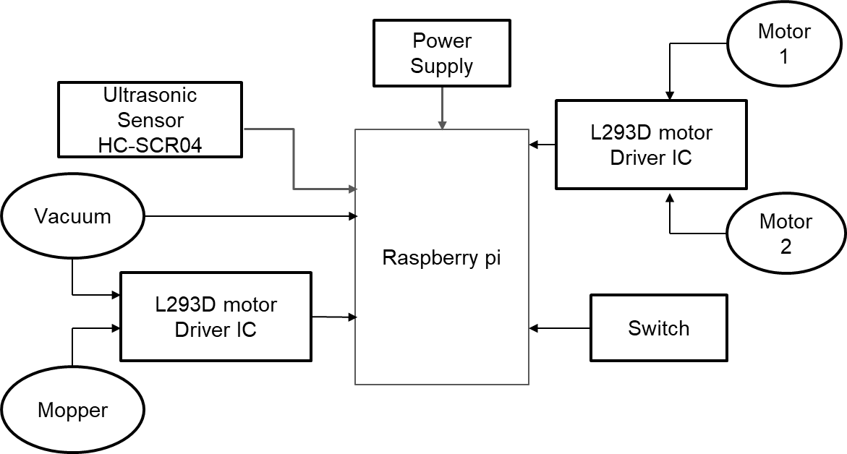

fig.4: Component connection with Raspberry pi

To integrate these components, appropriate wires and connectors were used. The switch was used to turn the bot on and off, and the ultrasonic sensor was used to detect obstacles in the path of the bot. When an obstacle was detected, the Raspberry Pi sent signals to the L293D motor driver to stop or change the direction of the DC motors. The vacuum and mopper were also controlled by the Raspberry Pi, and they were activated based on the dust prediction system's output.

Fig. 5 shows the prototype for the cleaning module. The vacuum cleaner suction part is placed at the front part with the dust collector at the top, while the mopping brushes are placed at the backside, so the combined work of vacuuming of dust and mopping of floor is done. A caster wheel is placed at the front side for the smooth motion of the bot on the floor.

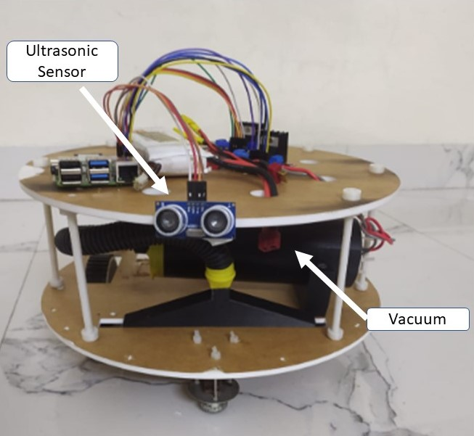

fig.5: Fully functional bot

Also the bot could be controlled manually with the help of Bluedot application. Blue Dot allows users to control the Raspberry Pi projects wirelessly – it is a Bluetooth remote application which is programmed in python language. It can be moved forward, backwards, left and right.

*C.**Open CV integration*

The Open Source Computer Vision Library (OpenCV) is a popular open-source computer vision and machine learning software library that provides various tools for processing visual data from cameras, images or videos. In this research, OpenCV was integrated into the development of an automatic cleaning bot to detect the presence or absence of dust on the floor and trigger the appropriate cleaning mechanism (vacuum or mop) based on the detection result. To detect the dust on the floor, the automatic cleaning bot was equipped with a camera mounted on top of it that captured a grayscale image of the floor area to be cleaned and then Gray-Level Co-occurrence Matrix (GLCM) technique was applied to extract texture features from the grayscale image which is a statistical method commonly used in image processing and texture analysis. The GLCM technique describes the second-order statistical properties of the image texture by computing the co-occurrence of pairs of pixels with certain spatial relationships and intensity values. In this paper, Four GLCM features were extracted: contrast, energy, homogeneity, and correlation. The extracted features were then used as inputs to a support vector machine (SVM) classifier The SVM is a machine learning algorithm that can be used for binary classification problems.

In this research, the SVM was trained on a dataset of labelled images (with and without dust) to learn the patterns of dust presence or absence based on the extracted features. Once trained, the SVM was used to predict the presence or absence of dust in real-time by classifying the features extracted from the current image. Based on the prediction result, the cleaning bot activated either the vacuum or mop mechanism. If dust was detected, the vacuum and mopping mechanism was activated to remove the dust from the floor. Otherwise, if no dust was detected, both the mechanisms were turned off. The OpenCV library provided the necessary functions to capture the grayscale image, extract the GLCM features, and perform the SVM classification. Fig. 6 below shows the webcam predicting “dust absent” for the clean area.

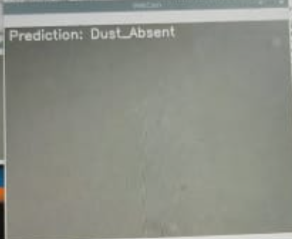

fig. 6:webcam showing the dust absent condition

Fig. 7 shows the webcam predicting “dust present” for the uncleaned area.

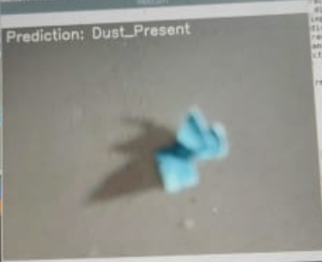

fig 7: webcam showing the dust present condition

In summary, the OpenCV library was integrated into the design of an automatic cleaning bot to detect the presence or absence of dust on the floor using the GLCM technique and SVM classification. The integration allowed the cleaning bot to perform real-time dust detection and activate the appropriate cleaning mechanism accordingly, leading to an efficient and effective cleaning process.

*D.**Automatic mode with obstacle avoidance and dust detection*

The cleaning bot was designed to operate in two modes: automatic and manual. In automatic mode, the bot used an ultrasonic sensor for obstacle avoidance and the GLCM technique of OpenCV integration for dust detection. The ultrasonic sensor was mounted on the front of the bot to detect obstacles in its path. When an obstacle was detected, the bot would automatically stop and change direction to avoid the obstacle. This feature helped to ensure that the bot could operate safely and effectively in a variety of environments. The dust detection system used the camera mounted on the top plate of the bot to capture images of the floor. These images were then processed using the GLCM technique of OpenCV integration to detect the presence or absence of dust. If dust was detected, the bot would activate the vacuum mechanism to remove the dust from the floor.

The automatic mode allowed the bot to operate autonomously without the need for human intervention, using an ultrasonic sensor for obstacle avoidance and the GLCM technique of OpenCV integration for dust detection. This helped to reduce the time and effort required for cleaning and allowed for more efficient use of resources such as water, cleaning solutions, and battery power.

*E. Manual control interface using Bluedot application*

In addition to the automatic mode, the cleaning bot can also be controlled manually using a mobile application called BlueDot. The application allows the user to toggle between the automatic and manual mode using two blue dots as shown in fig 8. To enable manual mode, the user needs to tap on the first blue dot. This will activate the manual control interface, which will allow the user to control the cleaning bot's movement manually. The user can move the cleaning bot forward, backward, left, and right using the virtual joystick on the screen. To return to automatic mode, the user needs to tap on the second blue dot. This will deactivate the manual control interface, and the cleaning bot will resume its automatic cleaning operation.

fig 8. Bluetooth Application

The BlueDot application communicates with the cleaning bot via Bluetooth connectivity. The cleaning bot is equipped with a Bluetooth module that allows it to receive commands from the mobile application. The application sends the commands to the cleaning bot in real-time, allowing the user to control the cleaning bot's movement smoothly and efficiently.

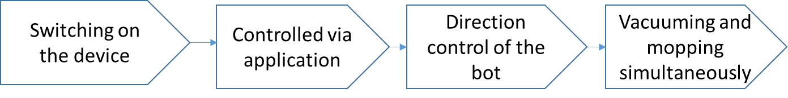

fig 5: The workflow for manual movement of the bot

In summary, the cleaning bot can be controlled manually using the BlueDot application, which provides a simple and intuitive interface for the user to control the bot's movement. The Bluetooth connectivity ensures real-time communication between the mobile application and the cleaning bot, allowing for smooth and efficient manual control.

IV. RESULTS AND DISCUSSION

An autonomous robot cleaning bot with the integration of openCV for dust detection has been designed with the features of vacuuming and mopping the floor using Raspberry Pi microcontroller. To evaluate the performance of the proposed automatic cleaning bot with dust detection using the GLCM technique of OpenCV integration, experiments were conducted in different environmental conditions in a standard-sized room.

In the study, a dataset of 3000 images was collected, with half of the images containing dust and the other half not. The dataset was used to train and test an SVM classifier to predict the presence or absence of dust using the GLCM technique of OpenCV integration. The accuracy of the classifier was measured using the confusion matrix, in which the SVM classifier achieved an accuracy of 92% in detecting the presence or absence of dust. The high accuracy rate obtained in this study demonstrated the effectiveness of the SVM classifier in predicting the presence or absence of dust. The results showed that the classifier can be used as a reliable tool to detect dust on the floor, which can then be used to activate the appropriate cleaning mechanism of the cleaning bot leading to faster cleaning times and reduced consumption of cleaning resources.

The proposed system was able to reduce the consumption of cleaning resources, such as water and cleaning solutions. The reason for this is that the cleaning bot with the dust detection system only activated the mop mechanism when dust was detected, which eliminated the need for water and cleaning solutions in areas that did not need cleaning. The autonomous mode of operation allowed the bot to navigate and clean floors without human intervention, which reduced the user's workload. The manual mode of operation also provided the user with the flexibility to control the movement of the bot in case it misses any spots or if there are any areas that require extra attention. The robot runs for a total duration of 35 minutes once it has started at its maximum rate.

V. CONCLUSION

The proposed model presented the design and development of an electronic bot for household cleaning that integrates OpenCV for dust prediction and an ultrasonic sensor for obstacle avoidance. The electronic bot was able to accurately predict dust accumulation and effectively avoid obstacles, improving the efficiency of the cleaning process. The cleaning bot was designed with a vacuum and mopping mechanism that could be operated in both manual and automatic modes wirelessly using an android application. The cleaning bot also demonstrated a high degree of accuracy in cleaning floors, with the ability to navigate and clean floors autonomously in automatic mode, or under manual control using the Bluedot application. With the implementation of this automatic floor cleaning bot, the cleaning process can be done in an easier manner and more efficiently. The development of this cleaning bot has the potential to revolutionize the way in which cleaning is performed in various environments, such as households, hospitals, and public places. The automatic mode of operation reduces the workload of the user, while the manual mode provides the user with the flexibility to control the movement of the bot and clean areas that require extra attention.

The findings of this study demonstrated the potential of using innovative technologies to improve cleaning efficiency and reduce human labor and can contribute to the development of more advanced and reliable electronic bots that can perform various cleaning tasks with minimal human intervention.

Future research can focus on the optimization of the cleaning bot's design, the improvement of the cleaning mechanism's efficiency, and the investigation of the cleaning bot's performance in various environments. The use of advanced image processing techniques and machine learning algorithms can also be further explored to develop more advanced cleaning bots that can detect and clean various types of dirt and debris. Additionally, the development of autonomous navigation systems can improve the efficiency and reliability of electronic bots, enabling them to perform more complex cleaning tasks with minimal human intervention. The scope can be accelerated by including GSM modules to the bot in order to make it function and handy from any part of the sector and convey a message that the robot has finished the cleaning task. Cleaner brushes can be brought to the hoover cleaning mechanism to boost the efficiency of dirt amassing. Lithium polymer batteries can be used in order to reduce the load of the bot which can in addition reduce energy consumption.

REFERENCES

[1] Adithya, P. S., R. Tejas, V. Sai Varun, and B. N. Prashanth. "Design and development of automatic cleaning and mopping robot." In *IOP Conference Series: MSE*, vol. 577, no. 1, p. 012126. IOP Publishing, 2019.

[2] Prayash, HA Shakhawat Hossen, Md Ragib Shaharear, Md Farhanul Islam, Saiful Islam, Noushad Hossain, and Shamik Datta. "Designing and optimization of an autonomous vacuum floor cleaning robot." In *2019 IEEE International Conference on Robotics, Automation, Artificial-intelligence and Internet-of-Things (RAAICON)*, pp. 25-30. IEEE, 2019.

 [3] Vishaal, Raj, P. Raghavan, R. Rajesh, Sachin Michael, and Mohan Rajesh Elara. "Design of dual purpose cleaning robot." *Procedia computer science* 133 (2018): 518-525.

 [4] Khan, Jahida, Udaysinh Bhapkar, Jitendra Bhat, Ashwini Chougule, and Sandesh Sangale. "Design and development of smart solar powered street sweeping machine." In *Materials Today: Proceedings* 46 (2021): 8663-8667.

 [5] Muthugala, MA Viraj J., SM Bhagya P. Samarakoon, Prabakaran Veerajagadheswar, and Mohan Rajesh Elara. "Ensuring Area Coverage and Safety of a Reconfigurable Staircase Cleaning Robot." in *IEEE Access* 9 (2021): 150049-150059.

 [6] Parween, Rizuwana, Manuel Vega Heredia, Madan Mohan Rayguru, Raihan Enjikalayil Abdulkader, and Mohan Rajesh Elara. "Autonomous self-reconfigurable floor cleaning robot." In *IEEE Access* 8 (2020): 114433-114442.

 [7] Murdan, Anshu Prakash, and Pawan Kumar Ramkissoon. "A smart autonomous floor cleaner with an Android-based controller." In *2020 3rd ELECOM*, pp. 235-239. IEEE, 2020.

[8] Parween, Rizuwana, Anh Vu Le, Yuyao Shi, and Mohan Rajesh Elara. "System level modeling and control design of htetrakis–a polyiamond inspired self-reconfigurable floor tiling robot." In *IEEE Access* 8 (2020): 88177-88187.

 [9] Veerajagadheswar, Prabakaran, Mohan Rajesh Elara, Thejus Pathmakumar, and Vengadesh Ayyalusami. "A tiling-theoretic approach to efficient area coverage in a tetris-inspired floor cleaning robot." In *IEEE Access* 6 (2018): 35260-35271.

 [10] Milinda, H. G. T., and B. G. D. A. Madhusanka. "Mud and dirt separation method for floor cleaning robot." In *2017 MERCon*, pp. 316-320. IEEE, 2017.

 [11] Saleem, Adeel, Atif Iqbal, and Adnan Sabir. "Design and implementation of an intelligent dust cleaner robot for uneven and nonstructural environment." In *2019 2nd iCoMET*, pp. 1-6. IEEE, 2019.

 [12] Zhong, Ruikang, Xiao Liu, Yuanwei Liu, Di Zhang, and Yue Chen. "Path Design for NOMA-Enhanced Robots: A Machine Learning Approach with Radio Map." In *2021 IEEE ICC Workshops*, pp. 1-6. IEEE, 2021.

 [13] Asafa, T. B., T. M. Afonja, E. A. Olaniyan, and H. O. Alade. "Development of a vacuum cleaner robot." In *Alexandria engineering journal* 57, no. 4 (2018): 2911-2920.

 [14] Ogiso, Satoki, Takuji Kawagishi, Koichi Mizutani, Naoto Wakatsuki, and Keiichi Zempo. "Self-localization method for mobile robot using acoustic beacons." In *ROBOMECH Journal* 2, no. 1 (2015): 1-12.

 [15] Sui, Linghui, and Lize Lin. "Design of household cleaning robot based on low-cost 2D LiDAR SLAM." In *2020 ISAS*, pp. 223-227. IEEE, 2020.

[16] Parween, Rizuwana, Leong Tze Lyn Clarissa, Min Yan Naing, Nur Aqilah Fitri Binte Mohamad Fuad, and Mohan Rajesh Elara. "Modeling and Analysis of the Cleaning System of a Reconfigurable Tiling Robot." in *IEEE Access* 8 (2020): 137770-137782.

[17] Le, Anh Vu, Phone Thiha Kyaw, Rajesh Elara Mohan, Sai Htet Moe Swe, Ashiwin Rajendran, Kamalesh Boopathi, and Nguyen Huu Khanh Nhan. "Autonomous floor and staircase cleaning framework by reconfigurable sTetro robot with perception sensors." In *JIRS* 101, no. 1 (2021): 1-19.

[18] Bormann, Richard, Joshua Hampp, and Martin Hägele. "New brooms sweep clean-an autonomous robotic cleaning assistant for professional office cleaning." In *2015 IEEE ICRA*, pp. 4470-4477. IEEE, 2015.

[19] Jarande, P. B., S. P. Murakar, N. S. Vast, N. P. Ubale, and S. S. Saraf. "Robotic Vacuum Cleaner Using Arduino with Wifi." In *2018 ICICCT*, pp. 1513-1517. IEEE, 2018.

[20] Pleshkova, Snejana, Zahari Zahariev, and Alexander Bekiarski. "Development of speech recognition algorithm and labview model for voice command control of mobille robot motio." In *2018 International Conference on High Technology for Sustainable Development (HiTech)*, pp. 1-4. IEEE, 2018.

[21] Raveena Ishalavath M, Sandhyashree N, Rakshitha R, Arpitha Shankar. “Design and Development of an Automated Floor Cleaning Robot for Domestic Application.”*in IJERT Volume 8* (2020): ISSN: 2278-0181

[22] Anmol Taneja, Gagan Bansal, Rohil Setia, Hema N.“Moedor Cleaning Robot.” *In IEEE Xplore* ( 2018 ): [10.1109/IC3.2018.8530503](https://doi.org/10.1109/IC3.2018.8530503)

[23] A.Vimala, S.Manikandan, T.S.Aravinth, S. Birundha Devi, S. Sathiya Gopika. *“Microcontroller Based Floor Cleaning Robot.” in IJITEE Volume-8* (2019): ISSN: 2278-3075

[24] S Yatmonom, M Khairudin, H S Pramono and A Asmara. “Development of Intelligent Floor Cleaning Robot”. *Journal of Physics (2019)*: 1413 012014

.

[25] Shravani Kamble, Surbhi Dorle, Manisha Kapgate, Harsha Sathawane, V. Buddhe.“Design and Development of Wireless Floor Cleaning Robot”*.in IJESC (2017*) Research Article.

[26] Sri Vishva R, Naresh R, Venkada Krishnan M.S. “An Automatic Cleaning Robot*” in IEEE Xplore (2021)* Part Number: CFP21OAB-ART; ISBN: 978-1-7281-9537-7

[27] Shripad Malavadikar, Swapnil Mungale, Toshika Johri, Harshad Lokhande. “Automatic Cleaner Robot.”in *IERJ*(2017), Volume 2 Issue 8 Page 2617-2620, 2017 ISSN 2395-1621

[28] R. Neumann Instituto de Carvalho, H.A. Vidal, P. Vieira, M.I. Ribeiro. *“Complete Coverage Path Planning and Guidance for Cleaning Robots.”in*

IEEE (2002): 97TH8280.